

Capstone Project Report
Report 4 – Software Design Specification

– Hanoi, Jan 2025 –

Table of Contents
I. Record of Changes 3
II. Software Design Document 4
1. High Level Design 4
1.1 Software Architecture 4
1.2 Package Diagram 4
1.3 Database Design 5
2. Detailed Design 7
2.1 <Feature/Function Name1> 7
2.2 <Feature/Function Name2> 8
3. Class Specifications 8
3.1 package_name1 8
4. Other Design Specifications 9

I. Record of Changes
Date | A*  M, D | In charge | Change Description
*A - Added M - Modified D - Deleted

II. Software Design Document

1. High Level Design

1.1 Software Architecture
[The content of this section includes the overall architectural diagram which includes the sub-systems and/or components, the external systems (if any), and the relationships (communication messages) among them. You need also provide the explanation for each of the diagram components (modules, sub-systems, external systems, etc.)].
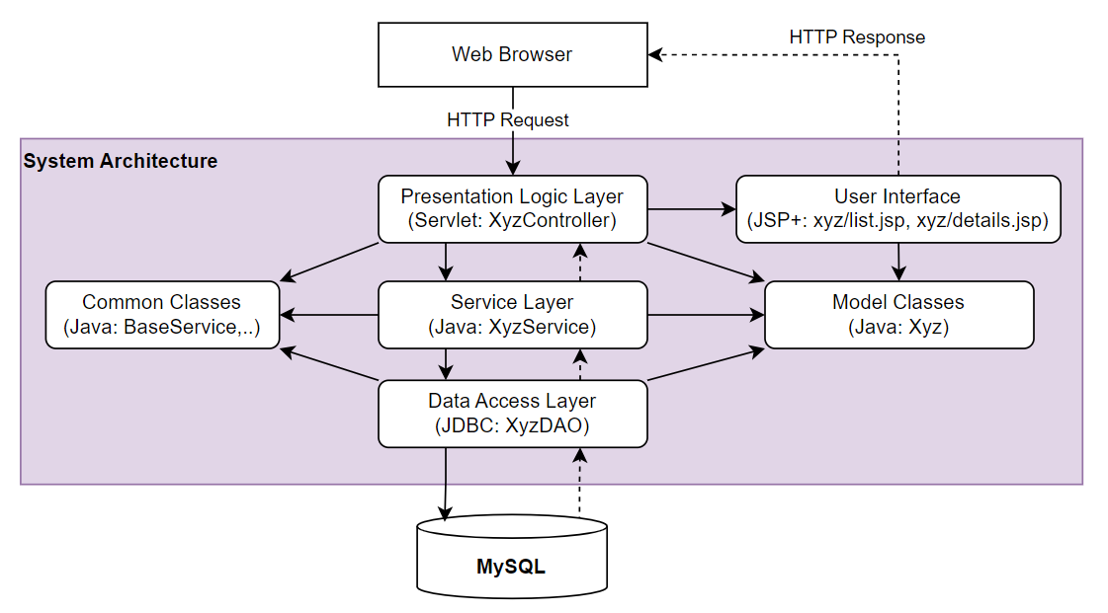-

1.2 Package Diagram
[Provide the package diagram for each sub-system. The content of this section including the overall package diagram, the explanation, package and class naming conventions in each package. Please see the sample & description table format below]
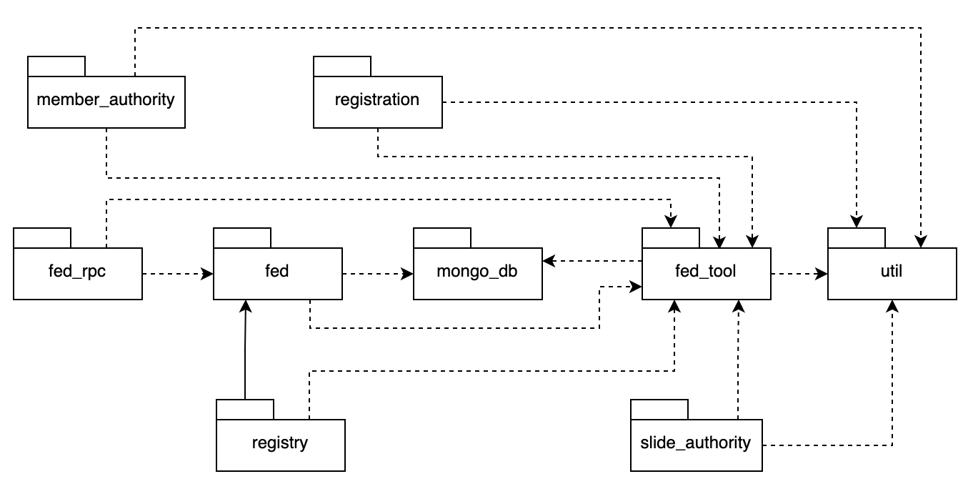
Package descriptions
No | Package | Description
01 | Member_authority | <Description of the package>
02 | registration | <Description of the package>
03 | …

1.3 Database Design
[Provide the files description, database table relationship & table descriptions like example below]

1.3.1 table_name1
[Provide brief description of the table here]
[Provide the detailed table fields description using below table format
* PK~Primary Key; FK~Foreign Key; UN~Unique; NN ~ not null
No | Field | PK | FK | UN | NN | Description
01 | <field_name1> |  |  |  |  | <Description of the field_name1>
02 | <field_name2> |  |  |  |  | …
..

1.3.2 table_name2
…

2. Detailed Design

2.1 <Feature/Function Name1>
[Provide the detailed design for the feature <Feature Name1>. It includes Class Diagram and Sequence Diagram(s); For the features/functions with the same structure of class & sequence diagrams, you need to provide the diagrams once for one feature/function and refer to those diagrams from other features/functions]

2.1.1 Class Diagram
[This part presents the class diagram for the relevant feature]
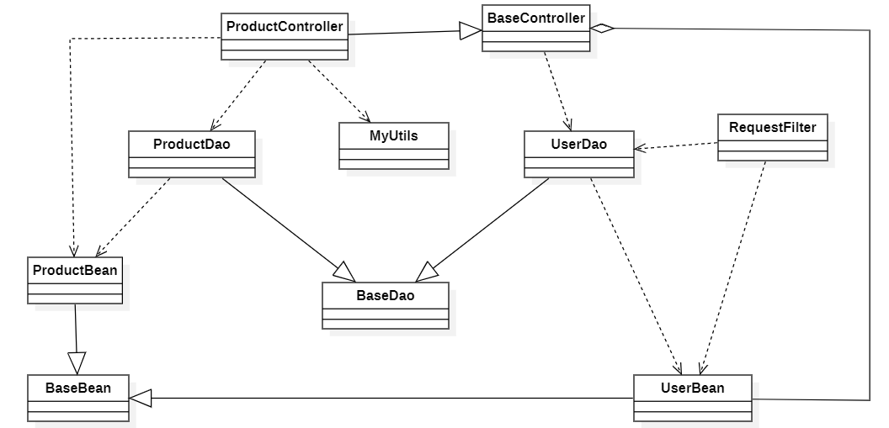

2.1.2 <Sequence Diagram Name1>
[Provide the sequence diagram(s) for the feature, see the sample below]
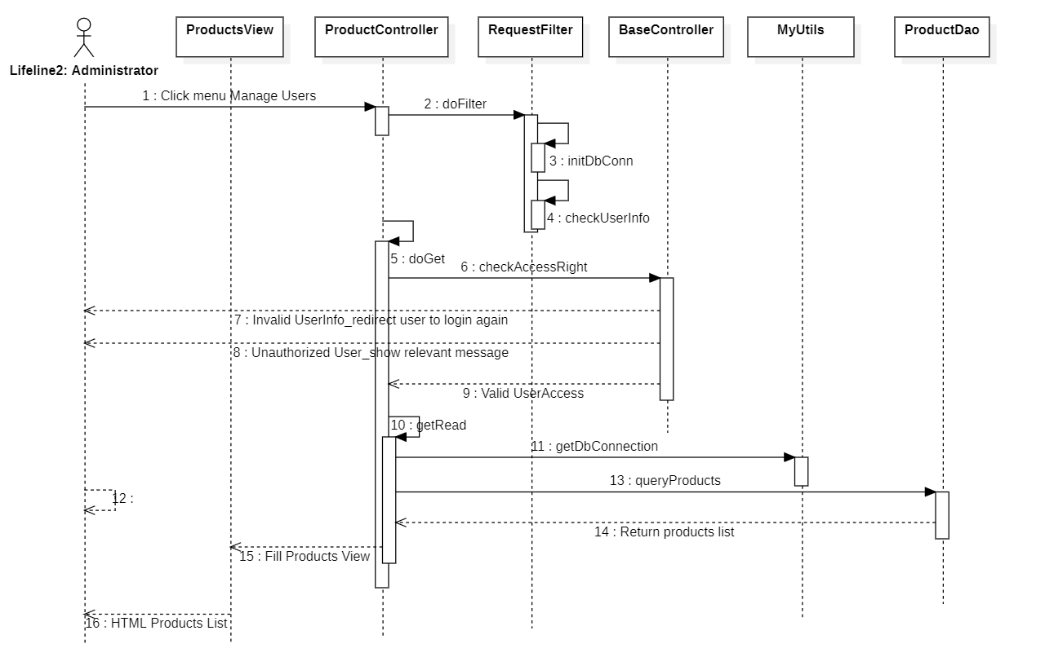

2.1.3 <Sequence Diagram Name2>

2.1.4 …

2.2 <Feature/Function Name2>
…

3. Class Specifications

3.1 package_name1
This section provides the detailed specifications for the classes in the package package_name1

3.1.1 ClassName1
[Provide brief description of the class here]
[Provide the class attributes and operations using below table format
No | Name | Description
Attributes
01 | <attributeName1> | Visibility: <attribute’s visibility: private, protected, default…>  Type: <data type of the attribute: int, String...>  Purpose: <description or purpose of the attribute>
02 | <attributeName2> | …
..
Methods/Operations
01 | <methodName1> | Visibility: <operation’s visibility: private, protected, default…>  Return: <void or return type of the operation: int, String,..>  Purpose: <description or purpose of the method>  Parameters: <<list out all the method parameters and provide details (name, data type, purpose/description) of each method parameter here  - paramName1:type1, purpose/description1  - paramName2:type2, purpose/description1  >>
02 | <methodName2> | …
..
]

3.1.1 ClassName2
…

4. Other Design Specifications
[Provide any other design specifications here: data design, system integrations, algorithms, etc.]

…

